**Research Questions**

1. What are the variables that affect hotel reservations cancellation?

2. How can we make hotel reservations cancellation better?

3. How will hotels be assisted in making pricing and promotional decisions?

**Hypothesis**

1. More cancellations occur when prices are higher.

2. When there is a longer waiting list, customers tend to cancel more frequently.

3. The majority of clients come from office travel agents to make their reservations.

**Analysis and Finding**

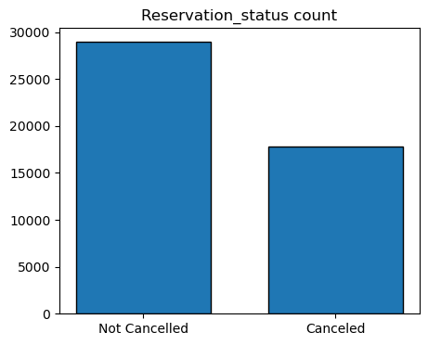

The accompanying bar graph shows the percentage of reservations that are cancelled and those are not. It is obvious that there are still a significant number of reservations that have been cancelled. There are still 37% of clients who cancelled their reservation, which has a significant impact on the hotel’s earnings.

In comparison to resort hotels, city hotels have more booking. It’s possible that resort hotels are more expensive than those in cities.

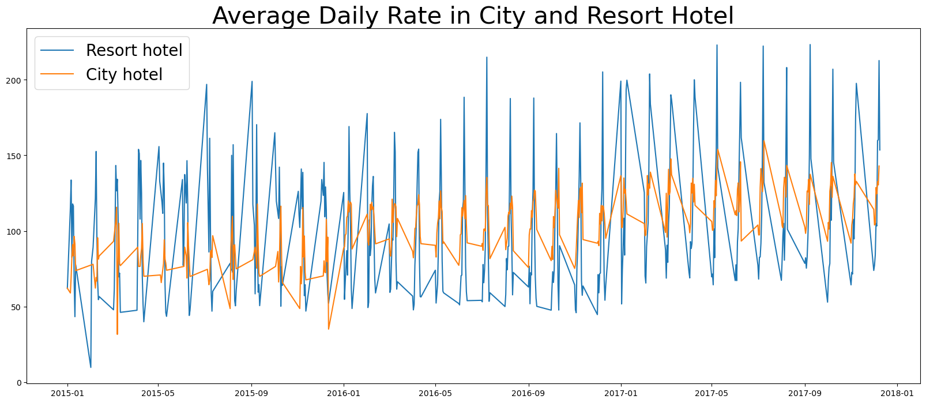

The line graph above shows that, on certain days, the average daily rate for a city hotel is less than that of a resort hotel, and on other days, it is even less. It goes without saying that weekends and holidays may see a rise in resort hotel rates.

We have developed a grouped bar graph to analyze the months with the highest and lowest reservation levels according to reservation status. As can be seen, both the number of confirmed reservations and the number of canceled reservations is largest in the month of August. Whereas June is the month with the most cancelled reservations.

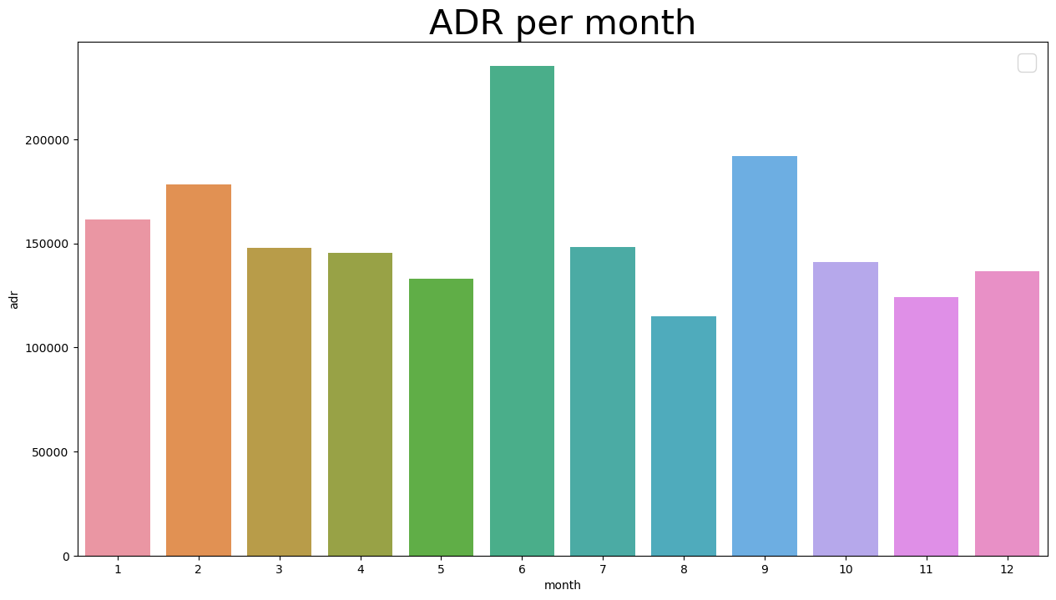

This bar graph demonstrates that cancellations are most common when prices are greatest and are least common when they are lowest. Therefore, the cost of the accommodation is solely responsible for cancelation.

Now, let’s see which country has the highest reservation canceled. The top country is Portugal with the highest number of cancellations.

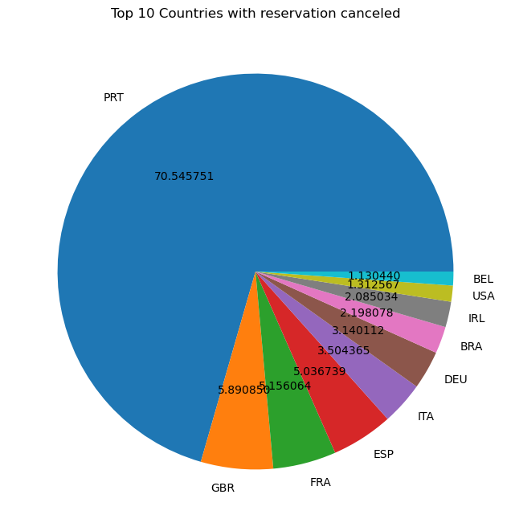

Let’s check the area from the guests are visiting the hotels and making reservations. It is coming from Direct or Groups, Online or Offline Travel Agents? Around 46% of the clients come from online travel agencies, whereas 27% come from groups. Only 4% of the clients’ book hotels directly by visiting them and making reservations.

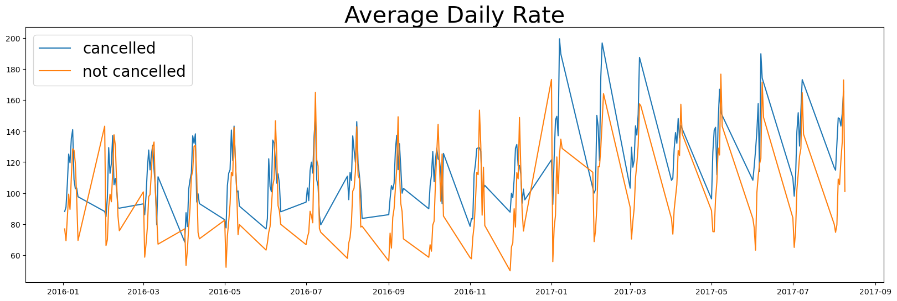

**Suggestions**

1. Cancellation rates rise as the price does. In order to prevent cancellation of reservations, hotels could work on their pricing strategies and try to lower the rates for specific hotels based on locations. They can also provide some discounts to the customers.
2. As the ratio of cancellation and not cancellation of the resort hotels is higher in the resort hotel than the city hotels. So, the hotels should provide a reasonable discount on the room prices on weekends or on holidays.
3. In the month of January, hotels can start campaigns or marketing with a reasonable amount to increase their revenue as the cancellation is the highest in this month.
4. They can also increase the quality of their hotels and their services mainly in Portugal to reduce the cancellation rate.